**Ideation Phase**

**Brainstorm & Idea Prioritization**

|  |  |
| --- | --- |
| Date | 28 June 2025 |
| Team ID | LTVIP2025TMID40768 |
| Project Name | Traffictelligence |
| Maximum Marks | 4 Marks |

**Brainstorm & Idea Prioritization**

Brainstorming fosters creativity by encouraging open participation, collaboration, and out-of-the-box thinking. The goal is to generate a high volume of ideas before refining and prioritizing them based on feasibility and impact.

**Step-1: Team Gathering, Collaboration and Select the Problem Statement**

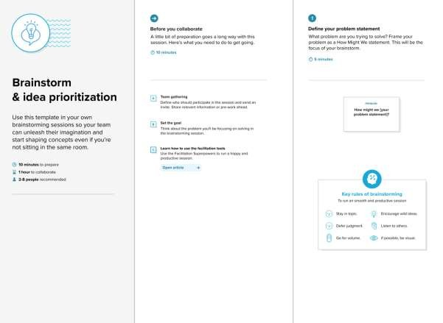

**Step-2: Brainstorm, Idea Listing and Grouping**

**\*\*Ideas**:**

|  |
| --- |
| 1. **Dynamic Lane Pricing: Implement surge pricing for express lanes based on congestion levels.** 2. **AI-Driven Detour Suggestions: Offer real-time alternative routes using predictive analytics.** 3. **Emergency Vehicle Priority: Sync with city EMS to clear traffic for emergency responders.** 4. **EV Charging Station Integration: Highlight and reserve charging spots along routes.** 5. **Crowdsourced Road Hazard Alerts: Users report potholes, accidents, or construction.** 6. **Personalized Commute Plans: AI generates tailored routes based on user preferences (e.g., scenic, fastest).** 7. **Public Transit Sync: Integrate live bus/train schedules for multimodal trip planning.** 8. **Carbon Footprint Tracker: Show emissions saved by chosen routes.**   **Grouping**   * **AI & Predictive Tech:** 2, 6, 8 * **Infrastructure Integration:** 1, 3, 4 * **User Engagement:** 5, 7 |
| **Prioritization(e.g., based on feasibility and impact):**   1. **Web app with machine learning (Implemented).** 2. **Real-time weather API integration.** 3. **Dashboard for traffic managers.** |

**Step-3: Idea Prioritization**

